**Knowledge Discovery Management Project**

**Increment-2 Report**

**Social Trend Analysis**



**Team:**

**Ashok Rudraraju,**

**Aditya Deshpande,**

**Tej Kiran Meka,**

**Mahesh Vemula.**

In this increment we have developed the script for refining the data extracted from Social Networking sites. The refined data contains the ID of the tweet or post and other attributes of the users. We have also developed the User Interface that we would like to represent for our project.

Below Screenshot represents the extracted raw data from the Social Networking sites.

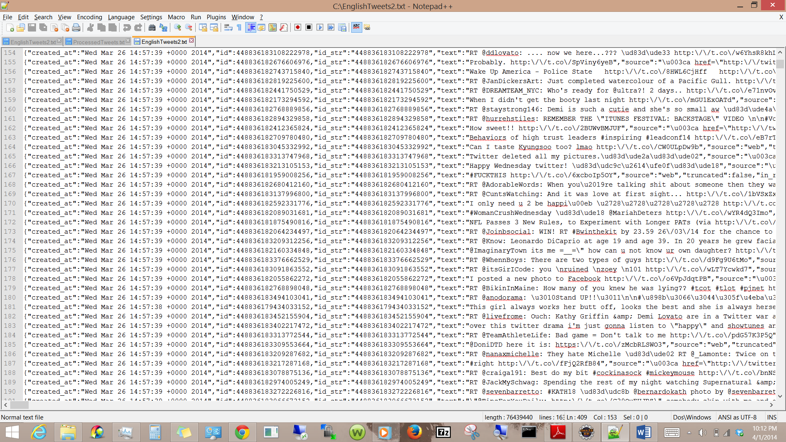

Following screenshot represents the refined data from the raw data.

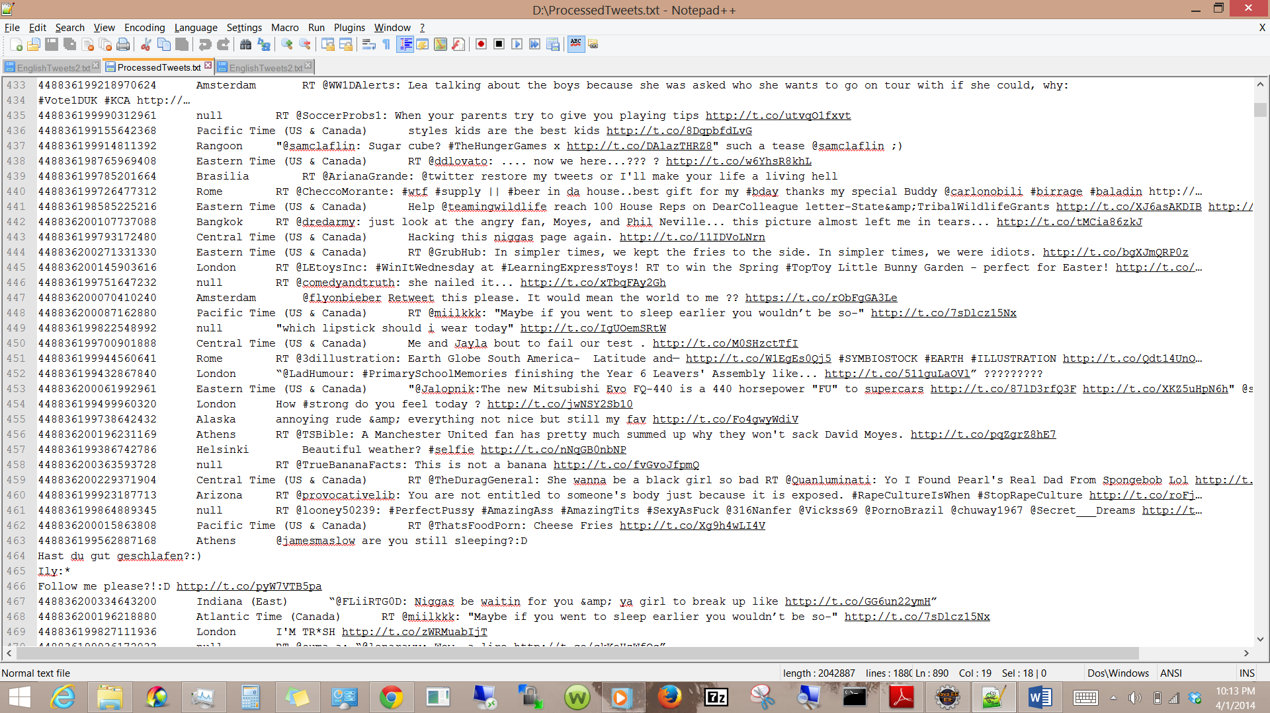

Below screenshot represents the script developed to refine the data.

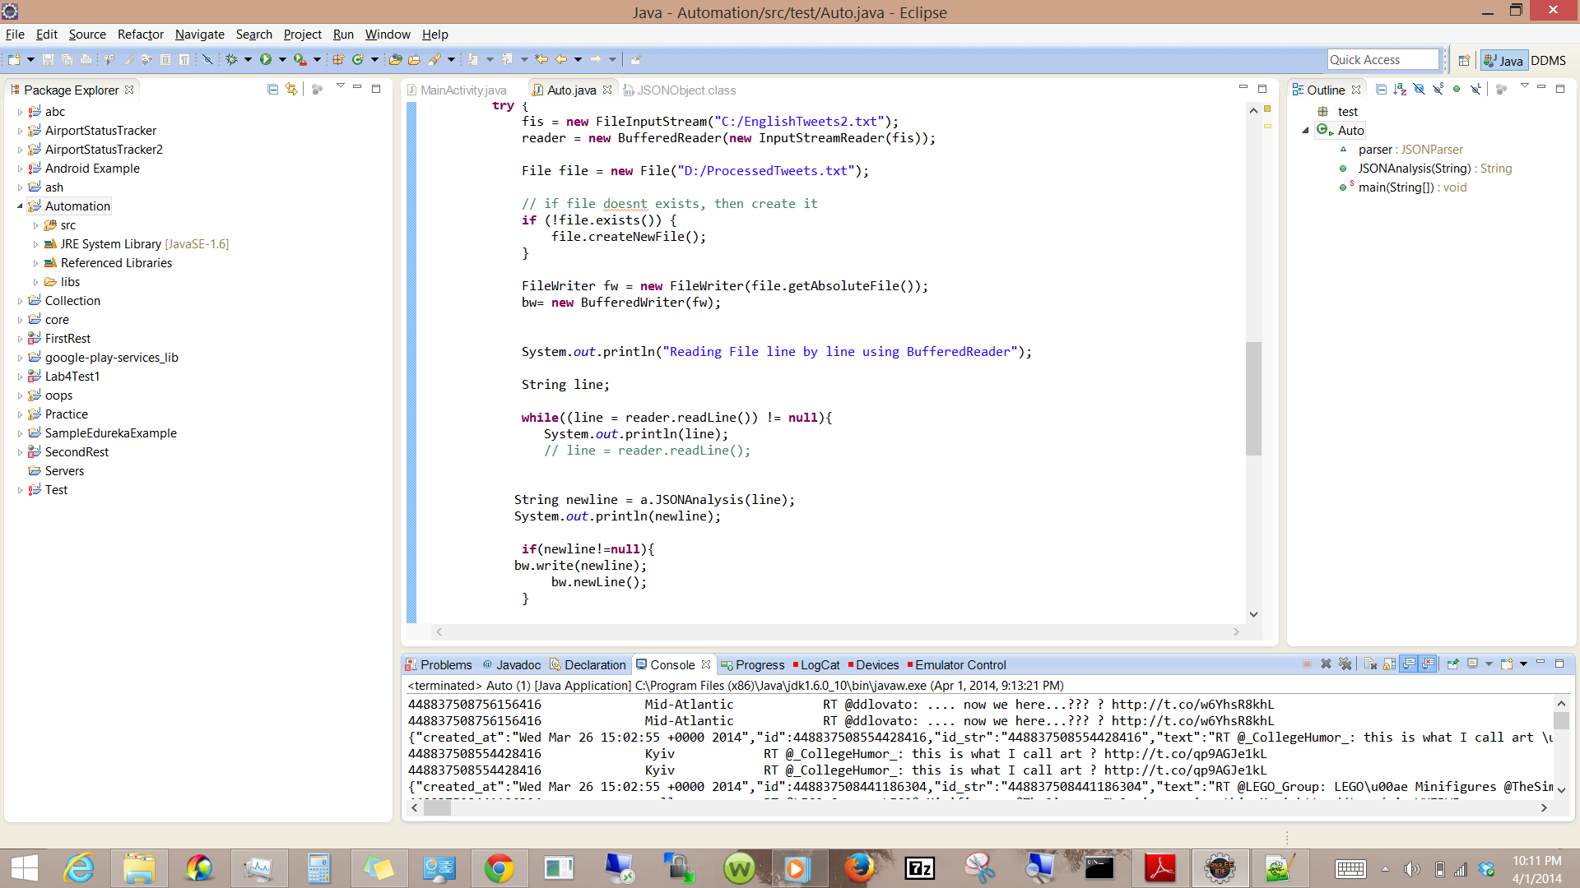

Following screenshot represents the Website we would like to present our project.

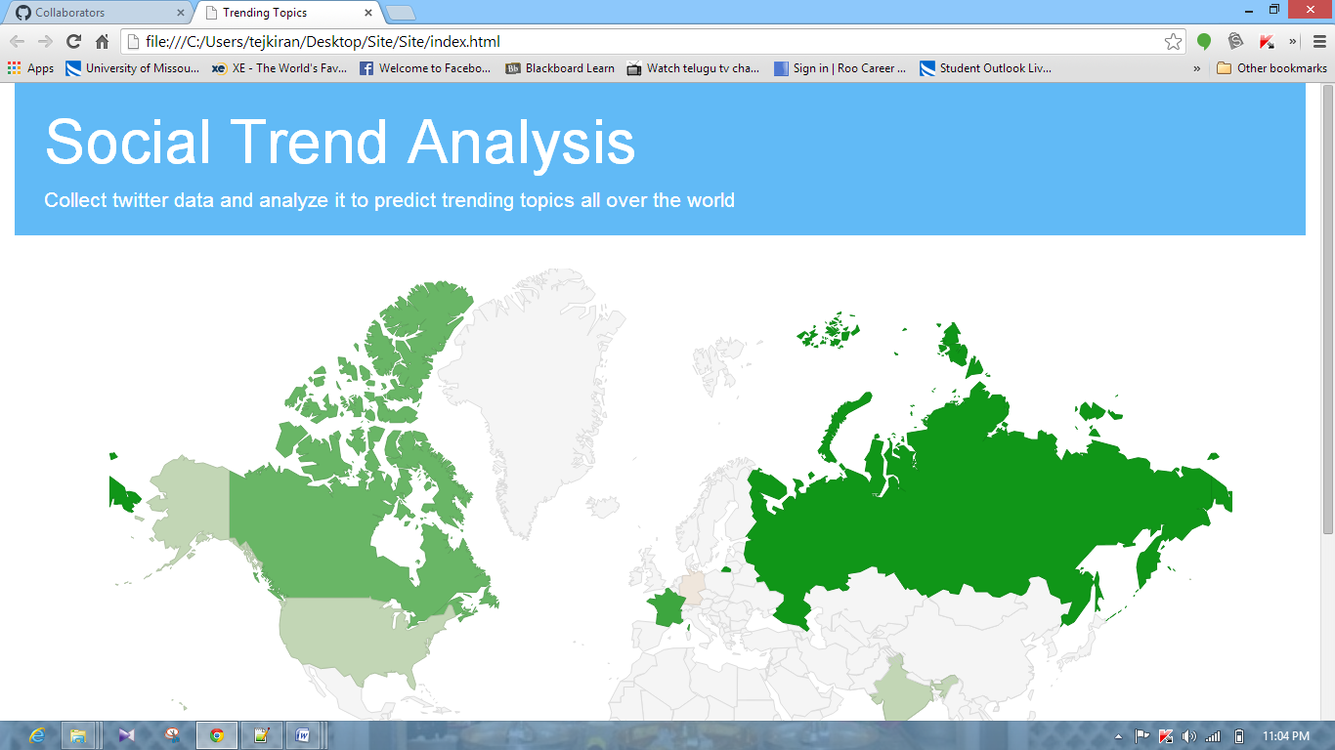

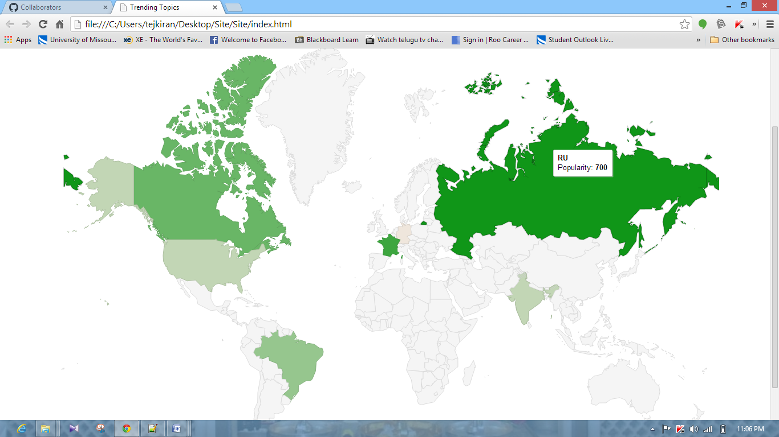

**Roles for the second Increment:**

Ashok Rudraraju, Tej Kiran Meka: Development of script to refine data.

Aditya Deshpande, Mahesh Vemula: UI Development, Analyzing the data.